|  |
| --- |
| **Teleopti Inc** |
| **Teleopti WFM - Amazon Connect Integration Requirements** |
| **2018-01-30** |
| Version 1.0 |
| |  |  |  | | --- | --- | --- | | **Who** | **Version** | **Change** | | Krista Crout, Teleopti Inc | 1.0 | First Version | | David Jonsson, Teleopti Inc | 1.1 | Added Teleopti Word Template | | David Jonsson, Teleopti Inc | 1.2 | Describe Standard Report vs. Interaction Data | | Krista Crout, Teleopti Inc | 1.3 | Add AWS Configuration | | David Jonsson, Teleopti Inc | 1.4 | Use Interaction Data only Add RTA details | | David Jonsson, Teleopti Inc | 1.5 | Switch agent identifier, add RTA logic | | Andreas Sjödin, Teleopti Inc | 1.6 | Add information about encrypted streams | | David Jonsson, Teleopti Inc | 1.7 | Update the AWS picture with some more details. Added Security section | | David Jonsson, Teleopti Inc | 1.8 | Add AWS SDK info | | Krista Crout, Teleopti Inc | 1.9 | Update to reflect automation from Cloud Formation Template | |

Table of Contents

2 Architecture Overview 4

3 Data integrations 5

3.1 Pre-requisites 5

3.2 Security 5

3.2.1 Encryption 5

3.2.2 End Points 5

3.2.3 What data? 5

3.2.4 Data At Rest 6

3.2.5 Data In Transit 6

3.3 Historical feed 6

3.4 RTA feed 7

4 Historical feed – details 7

4.1 Required Lambda Functions 7

4.2 AWS Additional Requirements 8

4.3 Data Mapping 8

4.3.1 Queue Statistics 8

4.3.2 Agent Queue Statistics 9

4.3.3 Agent Performance Statistics 10

5 RTA feed - details 10

5.1 Shards 10

5.2 Performance consideration 11

5.3 Encrypted Kinesis stream 11

5.4 Logic 11

6 Appendix – Setting up Amazon Services 12

6.1 Services required 12

6.2 CloudFormation Deployment 12

6.3 Amazon S3 Configuration 13

7 Appendix – Setting Data streaming for CTRs and RTA stream/Data Storage for reports 16

7.1 Assign Streaming Destinations 16

7.2 Assign Data Storage 16

7.3 Share RTA user credentials/stream with Teleopti 17

7.4 Setting up and Scheduling Reports 18

7.4.1 Login 18

8 Appendix – Encrypted streams 19

# Architecture Overview

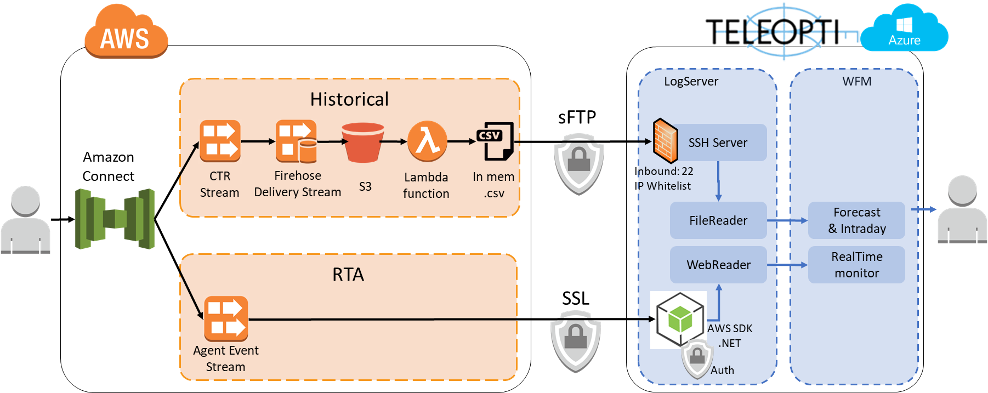

The picture above demonstrates the basic architecture of the integration. For the Historical feed, a firehose (+ 1 Report) saves Contact Trace Records into an Amazon S3 storage bucket (JSON data), where they are transformed into .csv files by a Lambda function and then transmitted via sFTP to Teleopti. The Teleopti sFTP server receives the files and uses them to generate WFM reports and forecasting models.

The RTA feed is more simplistic and will capture agent states, via a https request, filter them down to the last known state per agent and show that in Teleopti.

Agents and resource planners continue to use Connect, and now also have access to Teleopti via the web for scheduling, forecasting, intraday monitoring, and viewing reports.

This integration requires that the customer has an existing Amazon Connect instance, an existing Kinesis Stream plus few other Amazon Services and permissions and roles as outlined in the Appendix.

# Data integrations

## Pre-requisites

* a AWS Connect instance
* a AWS Kinesis stream
* a Teleopti sFTP hostname
* sFTP credentials (username + password)

## Security

### Encryption

Encryption on streams and S3 buckets are optional and but can be added within AWS for both services. Encryption does require additional configuration as both the IAM users and the FireHose role used needs to get access to the encryption keys to decrypt them from code. Please check with your AWS support contact for how to do this. See: **Appendix – Encrypted streams.**

### End Points

The **historical** feed does not need any public endpoint as the Lambda function will push the data to Teleopti over sFTP.

To get access to **RTA** you must implement either the *Kinesis Client Library (KCL)* or the *AWS SDK.* Both methods require you to authenticate to AWS Connect, from code, with a valid AWS IAM User (“Access Key ID” + “Secret Access Key”). The customer can easily block the AWS streams by rotating the Secret Access Key or by removing/changing the IAM User.

Teleopti uses a subset of the AWS SDK for .NET to consume the Agent Event stream:

* [AWSSDK.Core](https://www.nuget.org/packages/AWSSDK.Core/) (authentication)
* [AWSSDK.Kinesis](https://www.nuget.org/packages/AWSSDK.Kinesis/) (RTA events)

### What data?

The **Historical** data feed transferred contains [Queue ARN], [Queue name], [Agent ARN] and [Agent username] to identify the data. The metrics in the feed goes like: “how many calls”, “how many seconds in ACW”, etc. See: <https://github.com/Teleopti/AWS-Connect-Integration/blob/master/lib/jsontocsv.js>

No personal info about the origin of the call or any other personal information is touched on, collected or stored outside the AWS instance.

For **RTA** Teleopti access the AgentEvent Object on the Agent Event stream see: <https://docs.aws.amazon.com/connect/latest/userguide/agent-event-streams.html>  
Teleopti picks up three properties and sends them to the Teleopti WFM service:

* Configuration.UserName
* AgentStatus.ARN
* AgentStatus.Name

### Data At Rest

If encryption is added the JSON and report data stored in S3 is encrypted at rest.

The .cvs file created from a CTR only exists *in-Memory* within the Lamdba-function and never touches the S3 bucket “at rest”. The JSON CTR remains in the bucket until expiration, which is set by default to 30 days, but is configurable within S3. The Agent report .csv also remains in the bucket until expiration.

### Data In Transit

At this point the data is in clear text but sent over secure protocol.

The communication over the internet happens over sFTP/SSH (Historical) and https/SSL (RTA).

## Historical feed

The Teleopti AWS Cloud Formation Template will implement a “Amazon firehose” that will be connect to a “Contact Trace Report” stream and export all interactions into a S3 bucket. A Lambda-script transforms the data into .csv-files (in memory) which are pushed to Teleopti sFTP. The data is at this point still on a call (interaction) level and Teleopti will do the aggregation of the data into *intervals* using SQL Azure code given the customer’s choice of interval length, usually by 15 minutes.

Agents are identified using the Agent ***UserName*** from AWS  
Queue are identified using the Queue ***ARN*** from AWS

Teleopti will provide a QuickStart template, Teleopti will provide the customer with the following as input to the QuickStart:

* sFTP hostname
* sFTP username
* sFTP password

## RTA feed

Teleopti will use a Kinesis Data Stream in AWS. The AWS stream output can be shared between all (other) integrations the customer might have, or the customer may choose to create a stream specifically for the Teleopti integration. “Scale out” of the stream is done using “shards”, see: <https://docs.aws.amazon.com/streams/latest/dev/service-sizes-and-limits.html>

Every 5 sec Teleopti will pull the latest available state for all agents. The delta (agents that changed state since last pull) are passed on to the Teleopti WFM RTA web service to be displayed on the RTA web tools.

Teleopti will need to know

* Access Key ID
* Secret Access Key
* Stream ARN - the ARN of the stream dictates what **region** and **name** Teleopti will use to connect to the stream

Agents are identified using the Agent ***UserName*** from AWS.

# Historical feed – details

The data pushed through the firehose into the S3 bucket every x minute should match the interval length configured in the TeleoptiAnalytics datamart for a close(r) to real-time experience. Note the interval needs to end before Teleopti can aggregate it. Add a few more minutes for processing and timing of events; the aggregated numbers should be available 10-30 minutes after the interval ended.

Note:

* Data transformations are done according to section **Data Mapping**
* Agent data – interval length matters!  
  Agent data is not available in the firehose but is pulled from AWS Standard Reports. That data is currently only available at a **30min level** fromAWS. Teleopti have to pick this data up as is and usually split the data down to a 15min level.

## Required Lambda Functions

a. The Lambda function resides on a central repository, where it will be referenced by the Cloud Formation Template.

b. The Lambda code package consists of multiple .js modules, the dependencies bluebird, ssh2, and node-s3-encryption-client, while the dependency aws-sdk is provided natively by the Amazon environment.

c. A CloudWatch event created by the Cloud Formation Template calls the Lambda on a 30-minute interval. The Lambda accesses the SQS queue to determine which files have not yet been sent to Teleopti via SFTP. For each file:

a. The file is checked, and is determined to be an interactions file if it is not a .csv and an Agent Performance file if it is.

i. Interactions files are transformed from JSON to .csv and sent through SFTP to the Teleopti integration server.

ii. Agent Performance files are sent through SFTP to the Teleopti integration server as-is.

d. TeleoptiLogServer then aggregates the collected data, after which the ETL service pushes it to the data mart, making it available to the customer.

## AWS Additional Requirements

For Lambda to access the S3 buckets to read and write files, an IAM role with those permissions for all the relevant S3 buckets is created by the Cloud Formation Template.

The Lambda functions are provided the S3 bucket names for the incoming Connect reports and the client KMS key if encryption is requested by the Cloud Formation Template.

The SFTP server information for the Teleopti destination server is configured as input parameters by the Cloud Formation Template.

## Data Mapping

### Queue Statistics

|  |  |  |
| --- | --- | --- |
| Teleopti Field | Amazon Field | Notes |
| talking_call_dur | Agent_AgentInteractionDuration |  |
| wrap_up_dur | Agent_AfterContactWorkDuration |  |
| overflow_in_call_cnt | Count (TransferredToEndpoint) |  |
| overflow_out_call_cnt | Count(TransferCompletedTimestamp) |  |
| aband_call_cnt | Count(Agent_ConnectedToAgentTimestamp = null) |  |
| answ_call_cnt | Count(Agent_ConnectedToAgentTimestamp) |  |
| queued_and_answ_call_dur | Sum(Queue_Duration) | Filtered on answered as defined above |
| queued_and_aband_call_dur | Sum(Queue_Duration) | Filtered on abandoned as defined above |
| queued_answ_longest_que_dur | Max(Queue_Duration) | Filtered on answered as defined above |
| queued_aband_longest_que_dur | Max(Queue_Duration) | Filtered on abandoned as defined above |
| avg_avail_member_cnt |  | Not available |
| ans_servicelevel_cnt | Count(Queue_Duration < SLA) | SLA provided by customer, same for all Queues |
| wait_dur |  | Not available |
| aband_short_call_cnt | Count (Queue_Duration < 5) | Short call Threshold is 5 seconds by Teleopti default, a different value can be requested by customer |
| aband_within_sl_cnt | Count(Queue_Duration < SLA) | SLA provided by customer, same for all Queues |

### Agent Queue Statistics

Note: this report is based off the AWS Standard Report

|  |  |  |
| --- | --- | --- |
| Teleopti Field | Amazon Field | Notes |
| talking_call_dur | Agent_AgentInteractionDuration |  |
| wrap_up_dur | Agent_AfterContactWorkDuration |  |
| answ_call_cnt | Count(Agent_ConnectedToAgentTimestamp) |  |
| transfer_out_call_cnt | Count(TransferCompletedTimestamp) |  |

### Agent Performance Statistics

|  |  |  |
| --- | --- | --- |
| Teleopti Field | Amazon Field | Notes |
| tot_work_dur | Online time |  |
| pause_dur | Non-Productive Time |  |
| avail_dur | Online time - Non-Productive Time |  |
| wait_dur | Agent idle time |  |
| admin_dur |  | Not available |
| direct_out_call_cnt |  | Not available |
| direct_out_call_dur |  | Not available |
| direct_in_call_cnt |  | Not available |
| direct_in_call_dur |  | Not available |

# RTA feed - details

## Shards

An AWS Kinesis data stream is divided into Shards for performance reasons. Each Shard has a limited amount of throughput. See: <https://aws.amazon.com/kinesis/data-streams/faqs/>, currently: 2MB/sec data output and 1000 PUT records per second per Shard

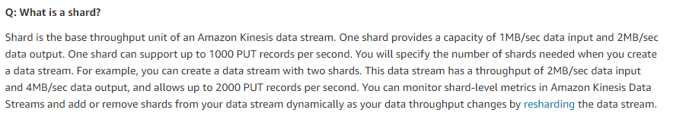

## Performance consideration

Many clients might share the stream but as the shard has a limitation on the throughput the customer need to consider planning number of shards. Given the data stream only servers the Teleopti RTA client, Teleopti suggest adding one Shard per 500 agents as a starting point.

## Encrypted Kinesis stream

It is possible to encrypt the stream at rest but is not needed from Teleopti’ s perspective. Encryption is done by setting up a KMS key and encrypt the stream with that key. The user that is used to read the stream must then have permission to use that key.

## Logic

At Startup the Teleopti Log Server (TLS) will pull all available data (for the last 24h) from each shard, this generates a big enough dataset to cover most agents, that either were active or logged off during the past 24h. Agents not available in that dataset will be given a default “logged out” state by Teleopti.

Once the first data 24h is collected by TLS it will start to fetch all states changes for the past 5 seconds. If multiple states are found for one agent TLS will post only the most recent RTA state change to the Teleopti WFM system. TLS sort the state changes by a AWS *SequenceNumber* which are global within each Shard. TLS will keep track of the last known SequenceNumber for the next 5 second data pull in memory - but will also persist the SequenceNumber to the database every 10 minutes - in case the Teleopti Integration service needs a restart.

The TLS will run the integration code for all Shards in parallel for better performance. Each agent (“username” used as identifier) will only be connected to one shard at any given point in time.

# Appendix – Setting up Amazon Services

## Services required

To complete the integration, the customer will be required to use the following Amazon Services:

* Amazon Connect – configuration already covered
* Amazon S3
* Amazon Cloud Formation

## CloudFormation Deployment

Using the link provided, you will be taken to the CloudFormation parameter entry screen. On this screen, enter a unique name for the stack and the S3 bucket to be created for your Teleopti Integration, as well as the SFTP hostname and credentials provided by Teleopti.

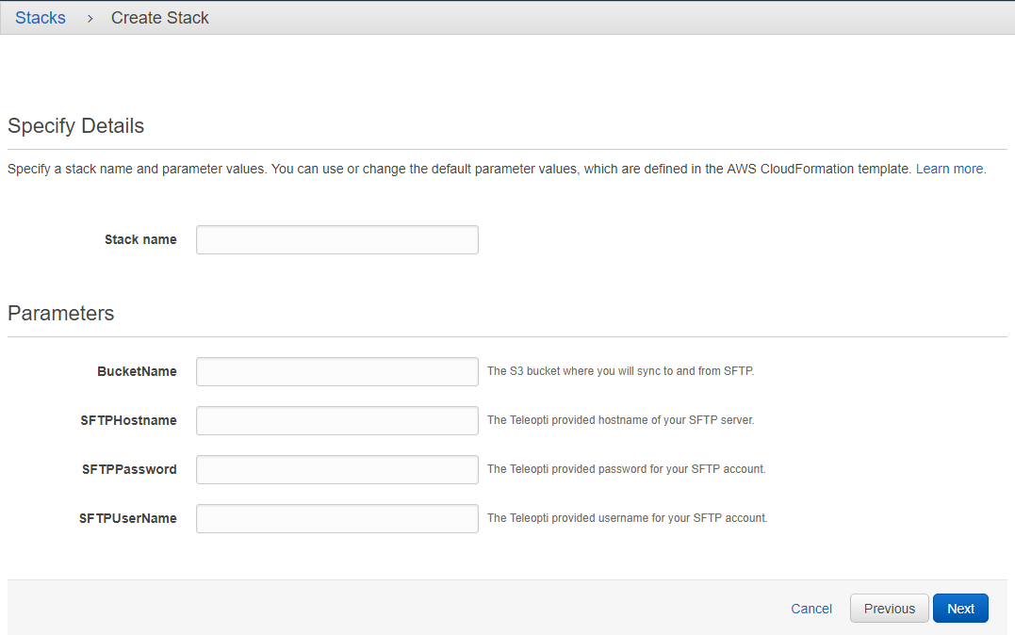

On the options page, leave everything default. Click Next.

On the Review page, make sure to check the box giving the stack permissions to create a new role. Click Create.

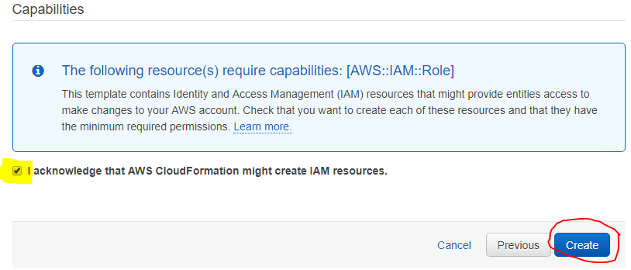

The creation of the stack will take a few minutes. You can hit the refresh button to check progress.

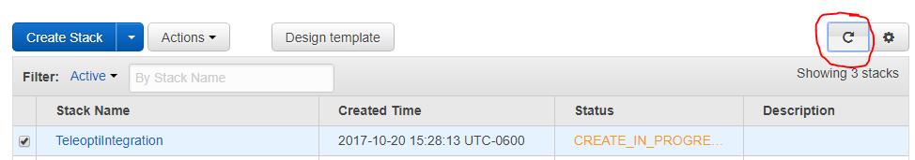

Once creation is complete, the page will automatically refresh. After creation, select the “Outputs” tab and save the information, it will be required for the following steps.

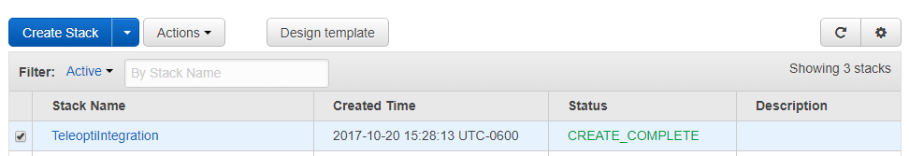

## Amazon S3 Configuration

Return to the AWS homepage and select S3.

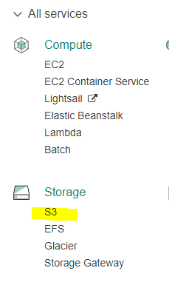

Open your newly created S3 Bucket.

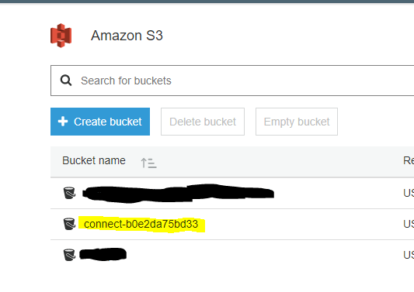

Select the Properties Tab.

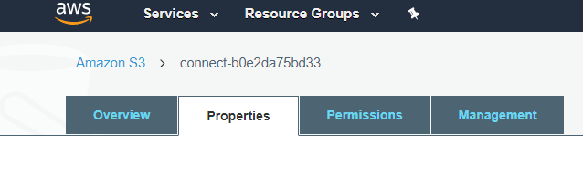

Select Events.

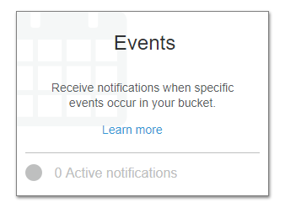

Click Add notification.

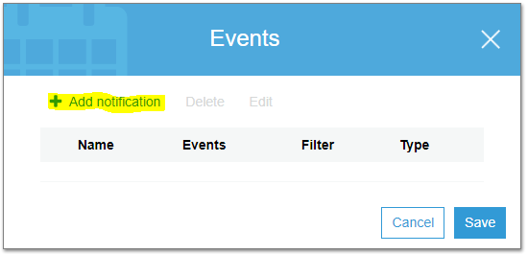

To configure the event, give it a name, check the box for ObjectCreate (All)

From the “Send To” dropdown, select SQS Queue.

From the “SQS dropdown”, select the name of your new SQS Queue.  
The name of the stream will be one of the outputs from the Cloud Formation.

Then click Save.

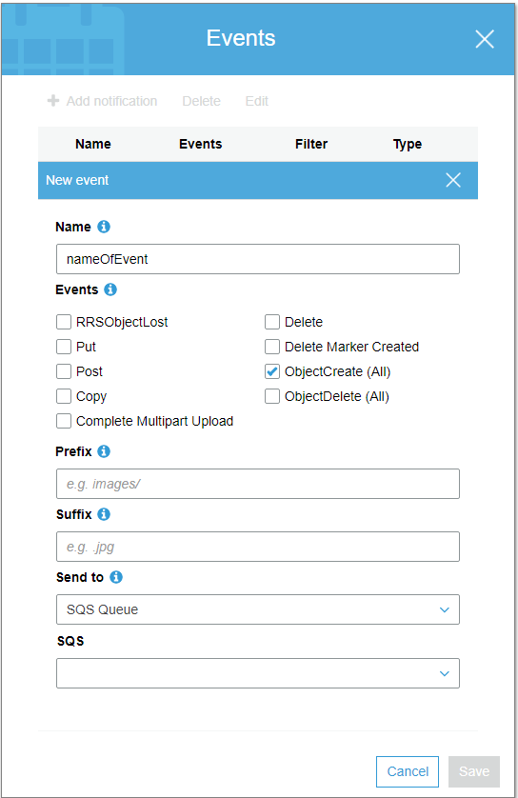

# Appendix – Setting Data streaming for CTRs and RTA stream/Data Storage for reports

## Assign Streaming Destinations

The Cloud Formation Template creates an IAM Group and an IAM User for accessing the Stream. It also creates a Kinesis Firehose Delivery stream for the Contact Trace Records. In the AWS console, open your Connect instance and select “Data streaming” to select the resources as destinations. For the Contact Trace records, select the name of the Firehose as provided in the Cloud Formation outputs. Under Agent Events, select the name of your existing stream. Click Save.

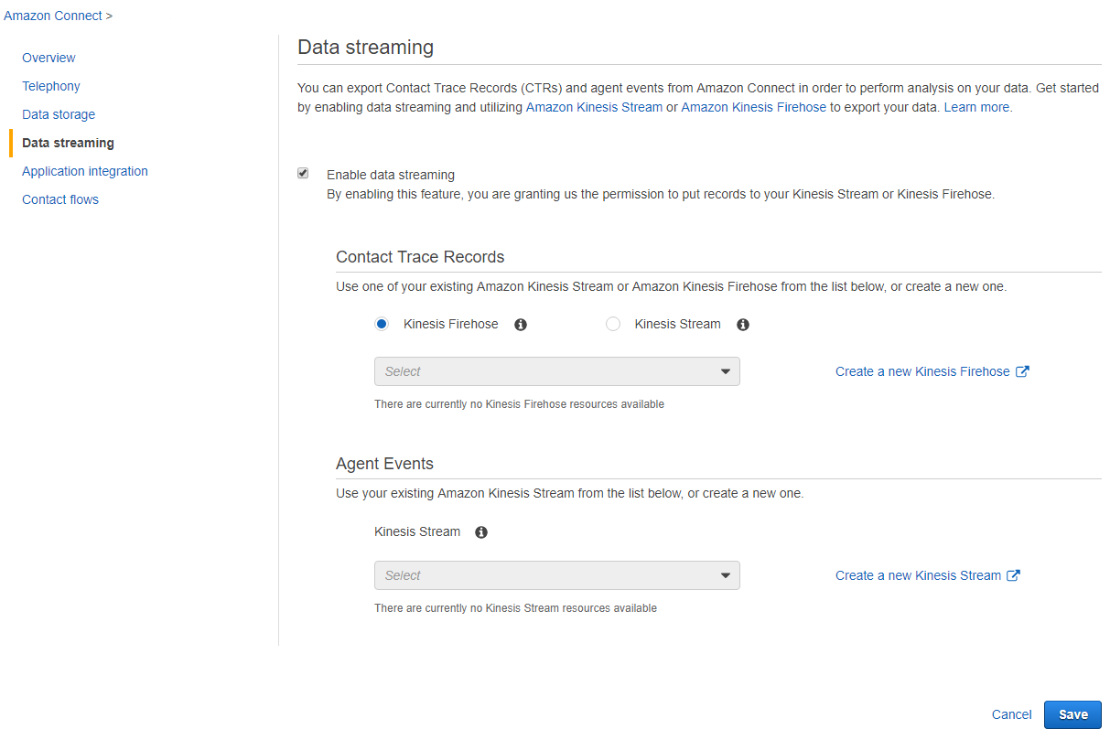

## Assign Data Storage

From the same screen, select “Data storage” to configure the bucket as the destination for your Agent Reports. Under Exported reports click Edit. Select “Enable exported reports” and pick “Select an existing S3 Bucket.” In the Name drop-down that appears, select the name of the bucket created during the CloudFormation process. Leave the prefix field empty and click Save for the Exported Reports section. Then click the Save button at the bottom of the screen.

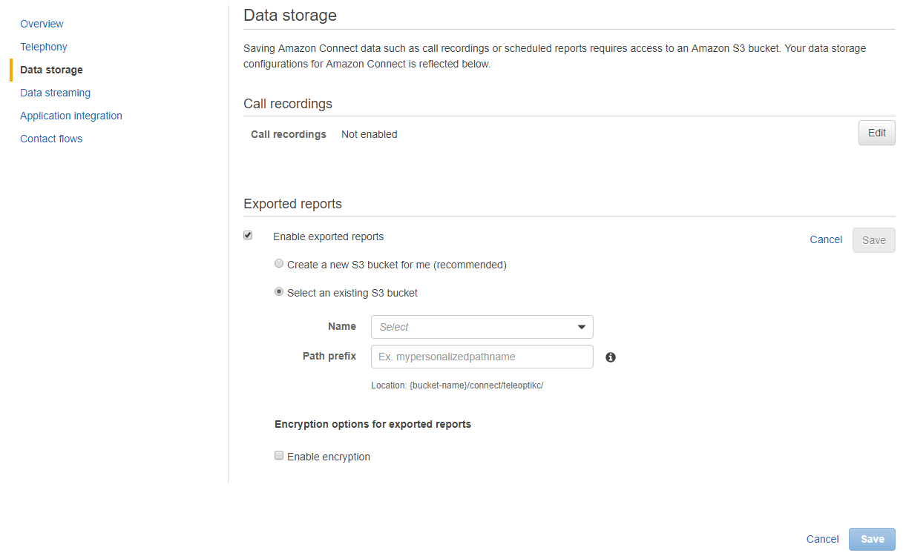

## Share RTA user credentials/stream with Teleopti

Using the outputs from the CloudFormation, collect the username of the IAM User, the Access Key, and the Secret Access Key. If you did not save the information, it can be retrieved from the CloudFormation section of the AWS console by selecting your stack and then Outputs.

Please Note: The Secret access key is only available on demand when logged into AWS.

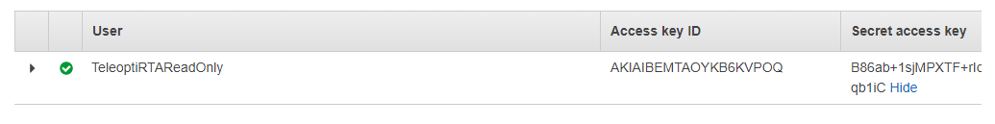

The “Kinesis data stream” which will capture Agent Events for RTA can be found here: <https://console.aws.amazon.com/kinesis/>

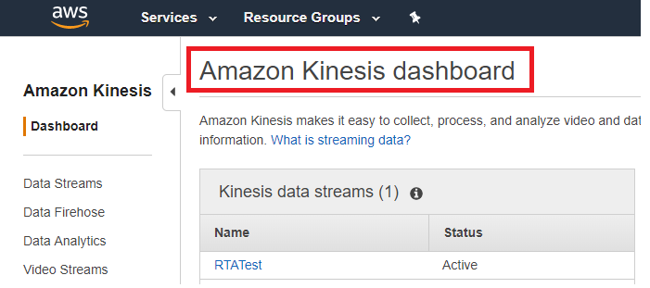

Click your stream **Name** to open the stream details. Copy stream ARN to send to Teleopti with the RTA user credentials.

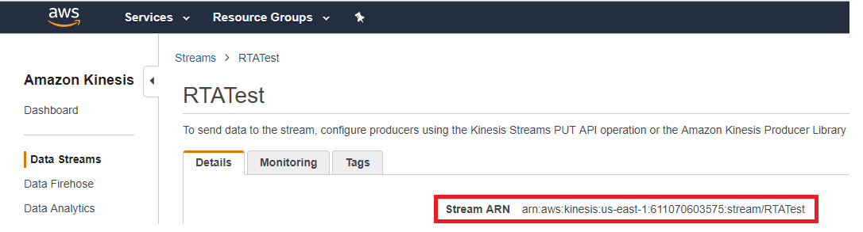

Send the collected information to your Teleopti Consultant.

## Setting up and Scheduling Reports

Creating the report should be done after following all other steps in the Appendix to set up the CloudFormation Stack. You will assign the S3 bucket as a destination for the reports during those steps.

### Login

* 1. Login to Connect and choose *Historical Metrics*.

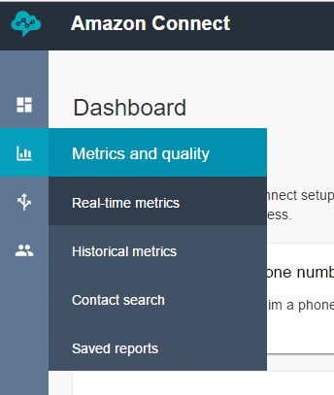

* 1. Configure your reports to include only to the Metrics Teleopti needs.  
     *Agent Performance Statistics:*  
     1. From the Historical Metrics page, click Queues, then click the gear in the upper right corner of the default report to open the Table Settings.
     2. On the Interval and Time Range tab, set the Interval to 30 minutes, leaving the Time Zone UTC and the Time Range Last 24 Hours.
     3. On the Groupings tab, ensure that “Interval” and “Agent” are selected.
     4. On the Metrics tab, ensure the following options are selected:
        1. Agent idle time
        2. Non-Productive Time
        3. Online time
     5. Click Apply.
     6. Click the arrow next to Save in the upper right corner, and select “Schedule.”
     7. Give the report a unique name and click “Continue.”
     8. Publish the report by clicking “Publish.”
     9. ReportName needs to be “TeleoptiAgentPerformance”
     10. Schedule the report to be delivered to the S3 bucket. On the Recurrence tab, set the report to be generated every half hour for the previous 2 hours.
     11. After clicking Create, Amazon will display a summary screen. The report has been successfully scheduled.
  2. Make sure the Reports are published to the S3 Bucket at the required times (Bucket names were configured under Connect Data storage option in the AWS console).

# Appendix – Encrypted streams

If encryption is needed: Then see below. According to Amazon this will be tied to an extra cost.

You can either use the default key named “(Default) aws/kinesis” or create a custom key.

Create the encryption key. Not needed if you use the default.

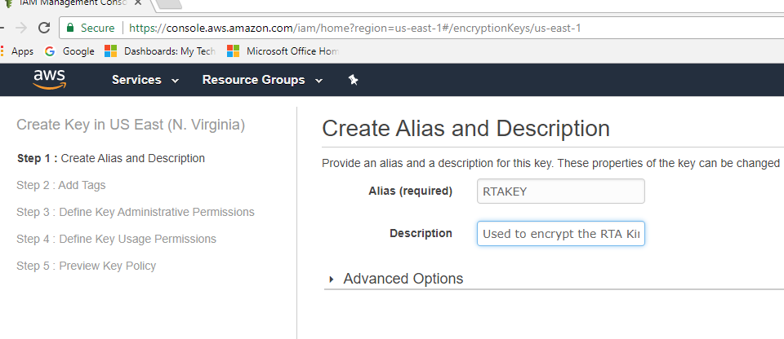

If a custom key is used then you must make sure to add permission for the user that will be used to read from the stream.

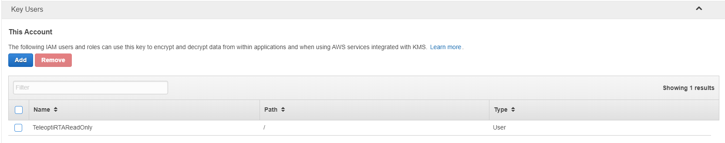

Go back to the stream and set the encrypt key that you would like to use.

